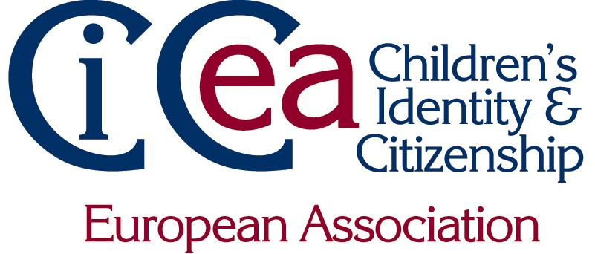

CiCea
Membership benefits

Association Members enjoy substantial advantages:

copies of our Journal: Citizenship Teaching and Learning

Citizenship Teaching and Learning is our academic refereed journal, with material of citizenship education from all over the world. Produced 3 times a year, and published by the academic publishers Intellect, this is the essential journal for all academics in the field! Individual members and Institutional members receive an electronic subscription.

use of our European Research Centres

we've set up eight European Research Centres scattered across Europe - Association members can book individual study places, or group research meetings, with hosts who will help access your accommodation requirements and local education establishments for research purposes. Members get an illustrated catalogue of the Centres at the beginning of the year/when they join.

access to our Research Support Grants

each year we run a Research Support Grant scheme, where we make supplementary funding available to help groups of members in collaborative research projects. Details of when and how to apply - and handy tips on making research funding applications – will be posted on the CiCea website: www.cicea.eu

reduced rates to our Conferences

members are eligible for a substantial reduction in the fees for our annual conference. The 2018 conference will be in Warsaw in May.

copies of our Newsletters

several times a year you'll receive our Newsletter, packed with news of activities,
conferences, publications and research opportunities.

vote and stand for Election
all members can stand for election - as President or Executive Members. Institutional
members get a larger block vote. Our next election is in the fall of 2018, for a President who will be on the Executive for six years and act as President 2012-14. The next Executive elections are in 2019. Only Association members can stand and can vote.

